


Lab Manual- Kubernetes Config Map

Prepared for:

Date: 18th Dec 2023

Prepared by:
Document Name: Lab Manual Document Number AZLabn916
Contributor:

Contents
1. Objective 3
2. Install and Set Up kubectl on Windows 3
3. Create 1 Node Azure Kubernetes Cluster 3
4. Connect the Kubernetes Cluster from azure PowerShell 4
5. Create a Deploy Kubernest Dashboard from helm chart 5
6. Access the Kubernetes Dashboard ( Local PowerShell) 6
7. Deploy Sample NGNIX Pod 10
8. Check NGNIX Pod in Kubernetes Dashboard 12

Objective

Objective Lab 1- ConfigMap for Environment

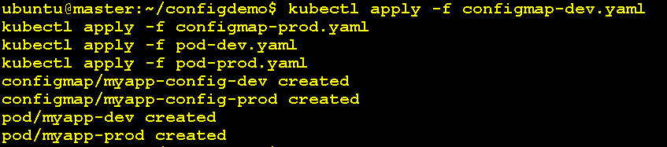

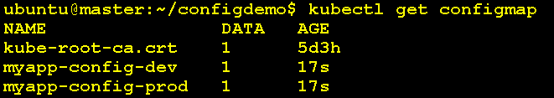

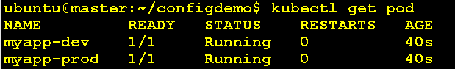

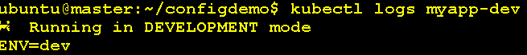

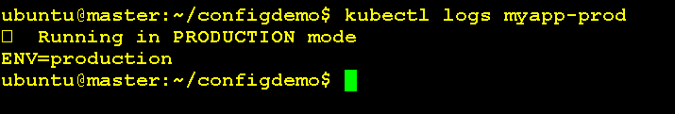

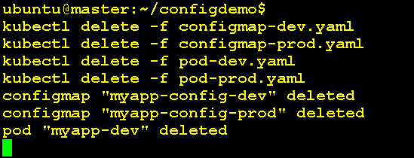

Lab 2- ConfigMap for Log

